Pre-Calculus/Trig3 Name
Unit 1 Review 1.3-1.9 Block Date

Graph the following equations.
1. 2. 3y = -6



Write the equation of the line in given the following information.
3. Through (0, -3) and (5, 2) 4. Parallel y = -2x + 5 thru (3,2) 5. Perpendicular to 2x–3y=-5
through (-1, 4)

State the domain and range of the following and determine if each is a function or relation.
6. {(4, -5), (2, 6), (3, -5), (-4, 0)} 7.

Domain: Domain:
Range: Range:
Function? Function?

State the domain of the following functions.
8. f(x) =$\frac{x+3}{x^{2}−5}$ 9. f(x) =$\frac{x^{2}−9}{\sqrt{x+2}}$

Solving algebraically find the zeros of the following functions.
10. f(x) = 3x² + 7x - 6 11. $f(x)=\frac{\sqrt{x^{2}−3}}{x+1}$

Given the graph, find the zeros, relative maximum and minimum values, and the intervals where the graph is increasing, decreasing or constant and the domain and range.

12. y = -2x³ –3x² + 1 13. y = (x – 1)² – 2

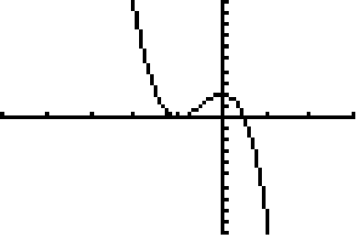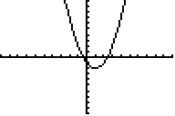

Find a) (f + g)(x), b) (f – g)(x), c) (fg)(x), and d) (f/g)(x). Identify any excluded values in the domains.
14. $f(x)=3x+2$ and $g(x)=x^{2}−5$ 15. f(x) = $\sqrt{x−4}$ and g(x) = -2x + 5

Find a) $(f∘g)(x)$ and b) $\left(g∘f\right)(x)$. Identify any excluded values in the domain.
16. f(x) = 3x -1 and g(x) = x² + x – 2 17. f(x) = 2x – 5 and g(x) = | x – 3|

18. State the parent graph and any transformations and sketch a graph of each of the following equations.

a) $f(x)=(x−3)^{2}−4$ b) $f(x)=\sqrt{−x+3}$ c) f(x) = ½ | x – 3| + 1

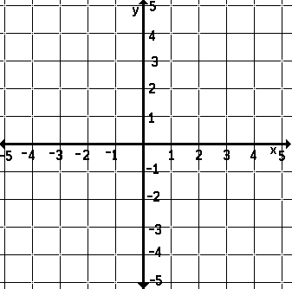

d) $f(x)=\frac{1}{x−2}+3$ e) $f(x)=−\sqrt{x+2}$ f) f(x) = (-x + 2)³ – 1

g) $f(x)=−x^{2}+2$ h) f(x) = 3(x - 2)³ +3 i) f(x)= -1/3 (x + 4)² +4

Determine if an inverse function exists. If so, find the inverse of each function.
19) $f(x)=\sqrt{3x+7}$ 20) $f(x)=x^{5}$ - 2 21) $f(x)=x^{2}+4$

22. Are the functions $f(x)=4x+8)$ and $g(x)=\frac{x}{4}−2$ inverses of each other?

23. State the domain and range of the following relation. 24. Is the inverse of this function a function?
Is it a one to one function? How do you know? How do you know?
$$\left\{(−1,2),(3,\text{10}),(−2,\text{20}),(3,\text{11})\right\}$$

Function Application Problems
25. In 2001, a person purchased a car for $25,290. After 11 years, the car will have to be replaced. Its value at that time is expected to be $1200. Use this information to write a linear equation that gives the dollar value of the car in terms of the year. Let t=1 represent 2001.

